Projects for Bjorn Mathisen. Programming Languages used are Python, C, C++, .Net, SQL, mySQL, Java and MASM32 Assembly. Any questions or requests for source code can be directed to Bjorn Mathisen at [contact@bjornmathisen.com](mailto:contact@bjornmathisen.com)

**Name**: Python Chatting Application with Server.

**Programming Language**: Python, SQL

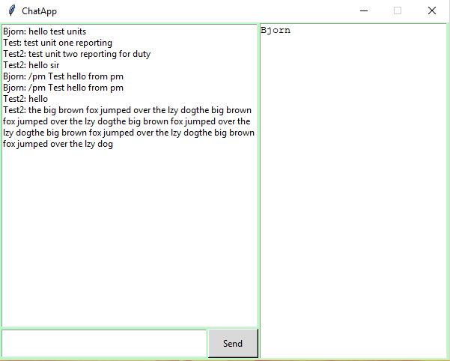**Description of Product.**

* Developed a UTC server to handle connections

from a GUI client sending group messages back

and forth.

* Programmed chat history and private messaging

for users.

* Created a database to maintain a list of users and

unsent messages.

* Created a GUI client with session handling

capabilities to facilitate access to the chat

server.

**Name**: MOD2 to Assembly Compiler

Programming Language: C#, Windows.Forms, MASM32

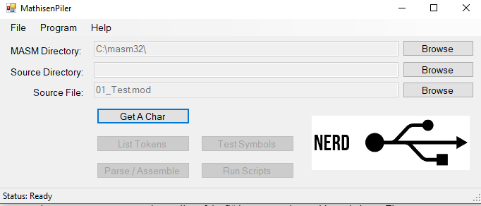**Description of Product**:

* Programed a Mod2 to MASM32

assembler capable of handling logical

statements and floating-point values up

to 32 bits.

* Developed a script to automatically

compile a series of MOD2 files and run

the assembled machine code checking

the desired output against the MOD2

output files.

* Learned how to use Linux piping, program multithreading and output streams.

Name: Club Budgeting Software Handler

Programming Language: C#, .Net, Windows.Forms, mySQL

**Description of Product:**

* 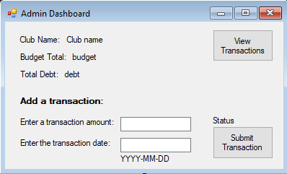Developed using a SCRUM style workflow within a team, using test driven development.
* Developed a SQL database with budgeting information in hashed protected data fields.
* Wrote a custom SQL library capable of handling large and verbose queries against the database using user search results.
* Automated tests were written in NUnit checking against numerous clauses.

Name: Music MIDI tracker and recorder.

Programming Language: C#, Windows.Forms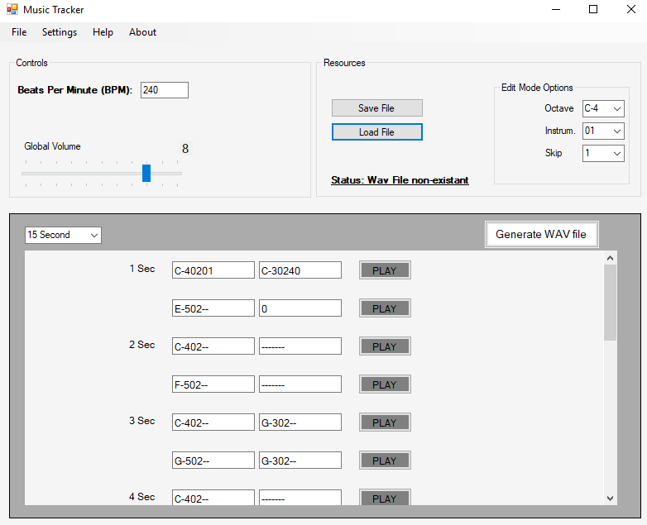

**Description of Product:**

* Programmed a music note recorder

using custom sine and triangle wave

generators to record tones and notes.

* Programmed multiple ‘instruments’

in the form of different tones and

pitches.

* Created a note file saving system to

load and save the songs.

* Played songs are used to generate

.wave files stored in the root

directory.

Name: Medusa 8 Bit microcontroller Computer

* Bridged the gap between the software and hardware teams to create a fully functional 8-bit computer using integrated circuits.
* Exercised exhaustive debugging, teamwork, and organizational skills while helping both teams communicate between each other to ensure success and blueprint correctness.
* Programmed EPROMs with OP code.
* Achieved best performance in school history.